**INTERNSHIP PROJECT REPORT**

**ON**

**SENTIBUDDY**

**BY JAYANT SINGH**

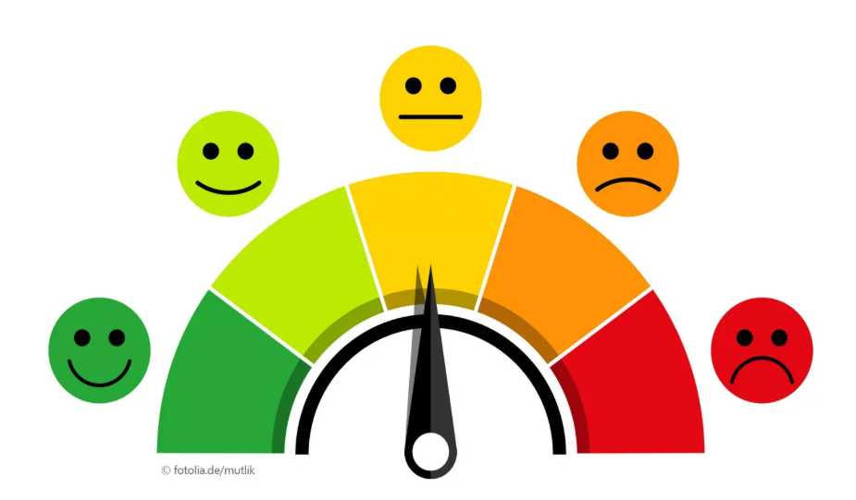

**ABSTRACT**

Sentiment analysis through artificial intelligence (AI) has become a cornerstone of competitive research, enabling businesses to uncover consumer emotions and opinions that drive market strategies. By classifying textual data into positive, negative, or neutral categories, AI models provide actionable insights into customer feedback, social media discussions, and competitor evaluations. This study investigates the role of AI-powered sentiment analysis in enhancing competitive market research, with a focus on identifying trends, assessing consumer attitudes, and benchmarking competitors’ products and services. To achieve this, both Gemini 2.5, a cutting-edge large language model, and BERT, a widely adopted transformer-based model, were applied to customer product reviews. The combination of these models offers a comparative perspective between advanced pre-trained LLMs and established machine learning approaches, ensuring a nuanced understanding of consumer sentiment. Findings from this work highlight the effectiveness of AI-driven sentiment analysis in providing deeper insights into market conditions, enabling businesses to strengthen strategies, outperform competitors, and foster stronger customer loyalty.

**TABLE OF CONTENTS**

**Chapter1: INTRODUCTION**

1.1 General Introduction

1.2 Current Open problems/Issues

1.2.1 linguistic approach

1.2.2 Machine Learning Approach

1.3 Problem Statement

**Chapter2: LITERATURE SURVEY**

**Chapter3: SYSTEM DESIGN**

3.1 Software Requirements

3.2 Hardware Requirements

3.3 Technology Used

**Chapter4: IMPLEMENTATION DETAILS**

4.1 Data preprocessing

4.2 Training of Model

4.3 Web scrapper

4.4 Designing UI

**Chapter 5: RESULT AND SAMPLE OUTPUTS**

5.1 Collective Analysis Web Design

5.2 Dropdown Box Collective Analysis

5.3 Product Improvement Recommendation

**Chapter 6: CONCLUSIONS**

6.1 Future Scope

6.2 Findings

***Chapter 1 - INTRODUCTION***

* 1. **General Introduction**

With the growing dependence on digital data, developing effective and scalable sentiment analysis systems is vital for any organization, whether business- or product-focused. Analyzing sentiment is also crucial for businesses of all sizes, in knowing and promptly responding to customers’ feedback or opinion on several topics. It plays an important role in various areas such as marketing, customer support, and product development by helping businesses accurately understand customer sentiments based on their feedback. Social platforms help professionals from various fields (business, marketing, sports, politics and product evaluation, etc.) rely on available approaches capable of analyzing user sentiments on topic of interest. This helps in better decision-making and in monitoring and shaping brand image through online platforms. Effective utilization of sentiment analysis methods allows companies to preemptively identify and address potential issues, thereby promoting a positive brand image. This research focuses on the utility of sentiment analysis for product-based organizations, highlighting its significance in managing customer relationships based on product reviews and feedback, which can help in changing product strategies and improvements accordingly.

In the digital era, the complexity and volume of online data have grown exponentially, driven by advancements in digital technologies. The types of data gathered online range from various product reviews on e-commerce platforms to comments on social media and discussions on blogs, which pose various types of challenges. These data are often unstructured, sprawling across various formats and languages, including informal slang, which complicates the sentiment analysis process. The volume of this data continues to increase, making manual analysis impractical. These challenges underscore the need for robust, automated sentiment analysis systems that can adapt and scale to keep pace with the evolving digital landscape. These automated systems are essential for businesses to harness insights into consumer behavior, market trends, product reviews, and overall brand perception, which are critical for strategic decision-making.

There are plenty of use-cases across the field, but to narrow down the scope, few use- cases related to product-based organizations are taken into consideration. In the perspective of variable sizes of organizations, sentiment analysis emerges as a crucial tool in this context for several reasons. Sentiment analysis is widely used in various sectors, including marketing, customer support, and product design, as it plays a vital role in understanding customer views and responses. By examining online discussions surrounding brands, companies can preemptively spot and tackle potential issues, thereby developing a favorable brand image.

* 1. **Current Open Problems/Issues**

**1. Linguistic Approach:**

It is the basic approach to dealing with sentiment analysis. It uses tagging technique with the tokens and then starts analyzing it. The problem with this approach is

* Negation: This approach cannot deal with negation very well. Few times, this

approach produces opposite in sense result.

* Grammatically incorrect sentences: This approach uses datasets to match words during tagging. So, if a sentence with polarity is formed grammatically incorrectly, it is not possible to match it with the existing data sets of polar words. The datasets must contain all the polar words used in regular language to make it more efficient
* Sometimes, users say something but mean something else type sentences in the text which make sense but are not analyzable by a machine.

**2. Machine-Learning-approach:**

There are methods which classify the text like naive bias or S_V_M also suffers from

problems like:

* Sarcasm
* Jumbling of words
* Chatting text or tweets
* Limited words to type
  1. **Problem Statement**

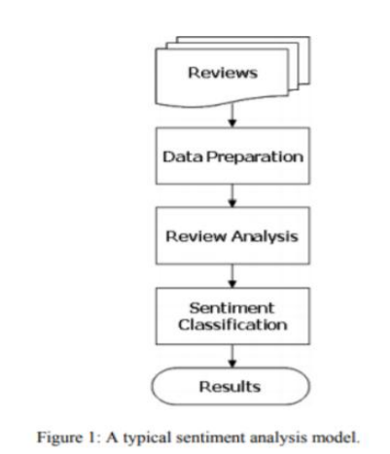

* Scrapping product reviews on various websites featuring various products specifically amazon.com.
* Analyze and categorize review data.
* Analyze sentiment on dataset from document level (review level).
* Categorization or classification of opinion sentiment into:
  + Positive
  + Negative
  + Neutral

***Chapter – 2 LITERATURE REVIEW***

**Paper 1 - Sentiment Analysis of Product Reviews Using Machine Learning and Pre-Trained LLM by Pawanjit Singh Ghatora ;Seyed Ebrahim Hosseini; Shahbaz Pervez and Nabil Shaukat**

Prior research has highlighted the effectiveness of combining traditional machine learning with large language models (LLMs) such as BERT for sentiment analysis. By examining multiple features like reviewing text and summaries, these methods provide a more nuanced understanding of customer perceptions. Studies further suggest that integrating LLMs into business strategies enables deeper sentimental insights, supporting better decision-making and product development.

Recent work also points to the potential of open-source LLMs, such as LLaMA 2, as cost-effective alternatives to proprietary models. Additionally, advancements like multi-threading, improved computational efficiency, and few-shot training techniques are seen as promising directions for achieving scalable and near real-time sentiment analysis. Together, these contributions emphasize the role of AI-powered sentiment analysis in driving customer-centric business strategies.

**Paper 2 – Comparative Study of AI Models for Sentiment Analysis by Zhang, H., Zhang, Z., & Song, Y.**

Several studies have compared the performance of traditional machine learning methods and transformer-based architecture in sentiment analysis. For instance, Zhang et al. evaluated models ranging from neural networks to transformers, concluding that transformer models captured subtle sentiments more effectively while reducing classification errors.

This body of work highlights the growing importance of AI in advancing sentiment analysis. Deep learning methods and advanced models, such as Gemini, have been shown to deliver more accurate insights into consumer sentiment, ultimately supporting better business decisions, strategic planning, and enhanced customer experience.

**PROPOSED SYSTEM**

The proposed system aims to perform sentiment analysis on customer product reviews using two advanced artificial intelligence models, Gemini 2.5 and BERT, applied individually for comparative analysis. The system is designed to evaluate the effectiveness of transformer-based architectures in extracting nuanced insights from unstructured textual data, which can be utilized for competitive market research.

***CHAPTER – 3 System Design***

**3.1 Hardware Requirements:**

* Core i5/i7 processor
* At least 8 GB RAM
* At least 30 GB of Usable Hard Disk Space

**3.2 Software Requirements:**

* Python 3.x
* Anaconda Distribution
* Any Operating System.

**3.3 Technology required:**

* Python
* Pandas
* Scikit learn
* Flask
* Gemini api
* BERT
* Javascipt
* Html 5
* Web scrapping(beautiful soup4)
* Database handling
* Dash from plotly

***CHAPTER 4 IMPLEMENTATION DETAILS***

**4.1 DATA PREPROCESSING**

Data acquisition is the key step because the quality of the data will influence the results derived from it. The intent was to experiment and see the effectiveness of machine learning techniques in sentiment analysis and that can also be achieved using a public dataset. Hence, a public dataset from Kaggle was leveraged, which was taken from Kaggle. Reviews were the primary data used for sentiment analysis. However, the dataset contained 24,664 records with null entries in the review field. These null records were removed to ensure the integrity and effectiveness of the sentiment analysis process. To ensure the reviews are balanced across sentiment categories (i.e., positive, negative, and neutral), a balanced data set was constructed. There are about 8,807 reviews in each Sentiment class, for a total of 26,421 labeled reviews for training and testing.

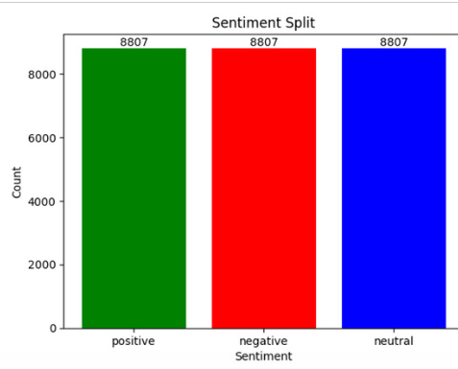 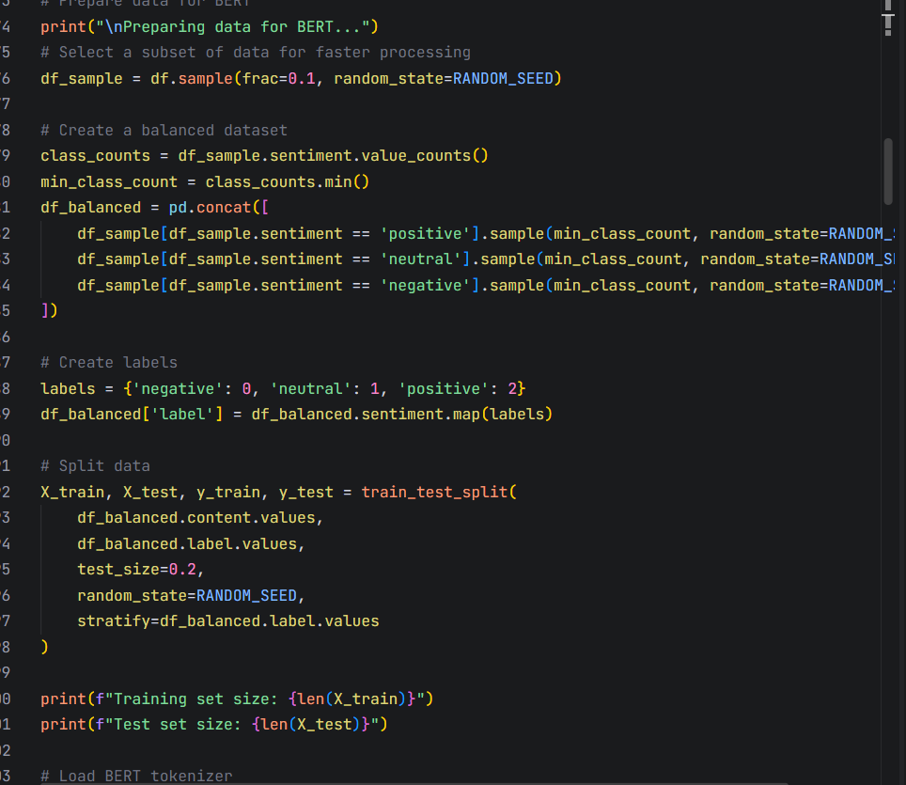

**4.2. Training the model**

Using preprocessed data and machine learning algorithms model was trained.

**4.2.1 BERT Model**

BERT (Bidirectional Encoder Representations from Transformers) is a transformer-based deep learning model developed by Google that captures bidirectional context from text. It is widely used for natural language processing tasks such as sentiment analysis, question answering, and text classification due to its strong contextual understanding.

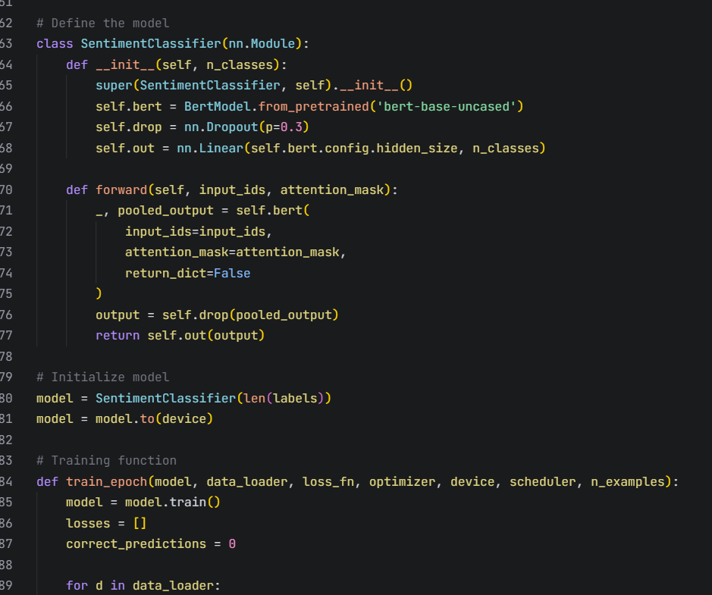 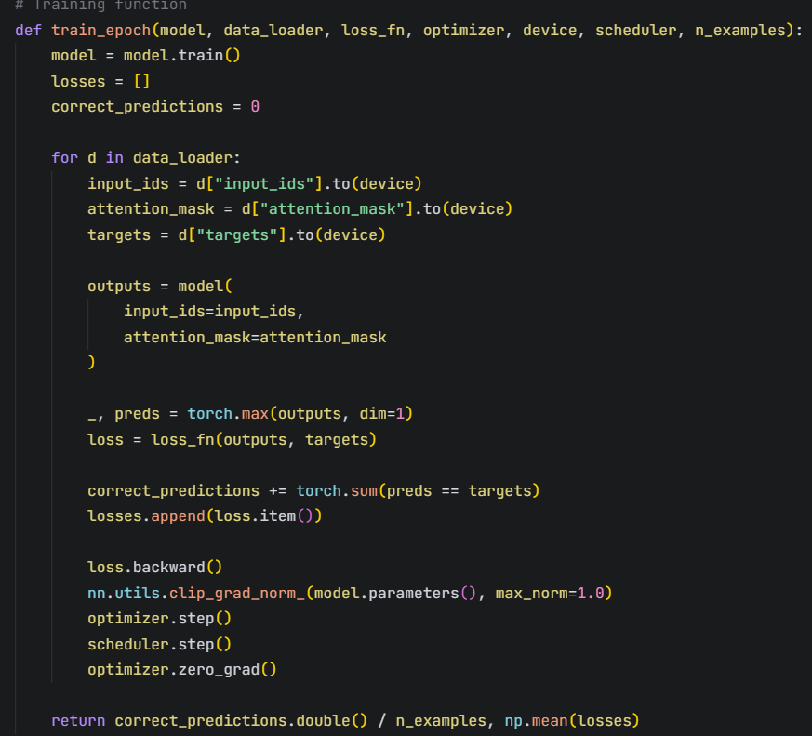 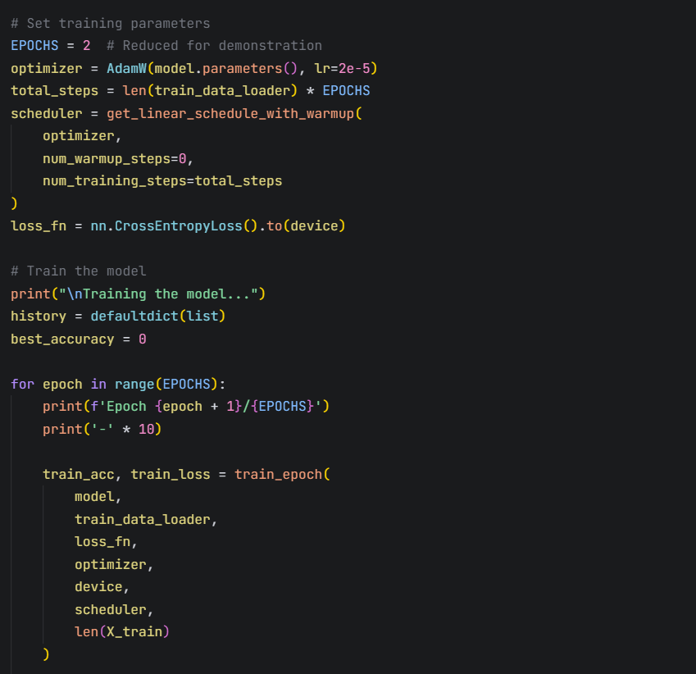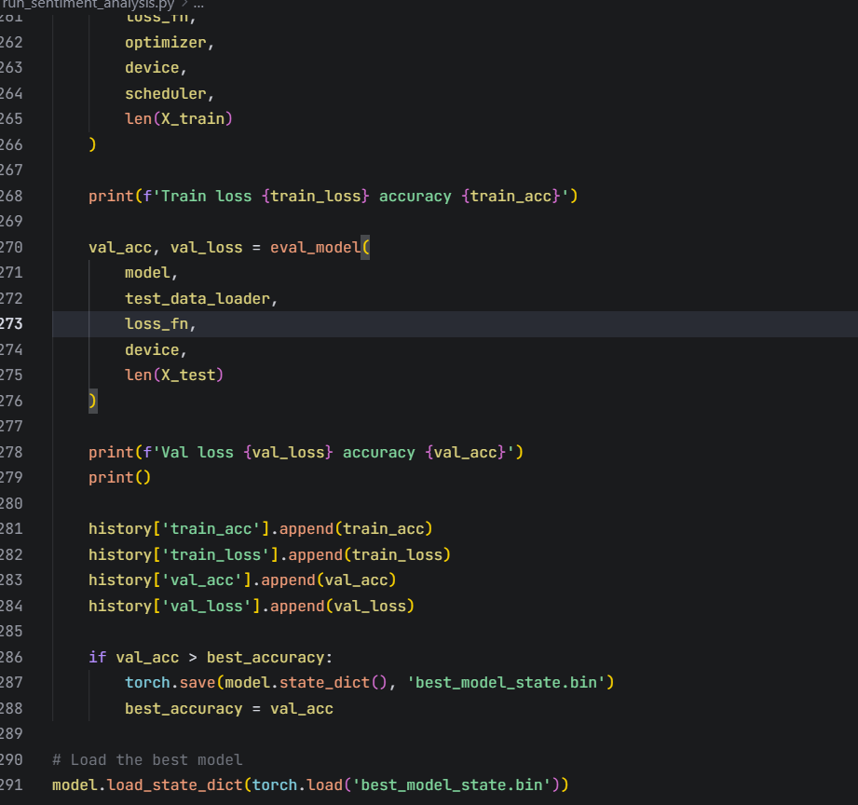

**4.2.2 Gemini model**

Gemini 2.5 is Google DeepMind’s advanced large language model designed for high-accuracy reasoning, multilingual understanding, and contextual analysis. It builds on the transformer architecture, enhanced with reinforcement learning and multimodal capabilities, making it effective for complex tasks such as sentiment analysis and competitive research.

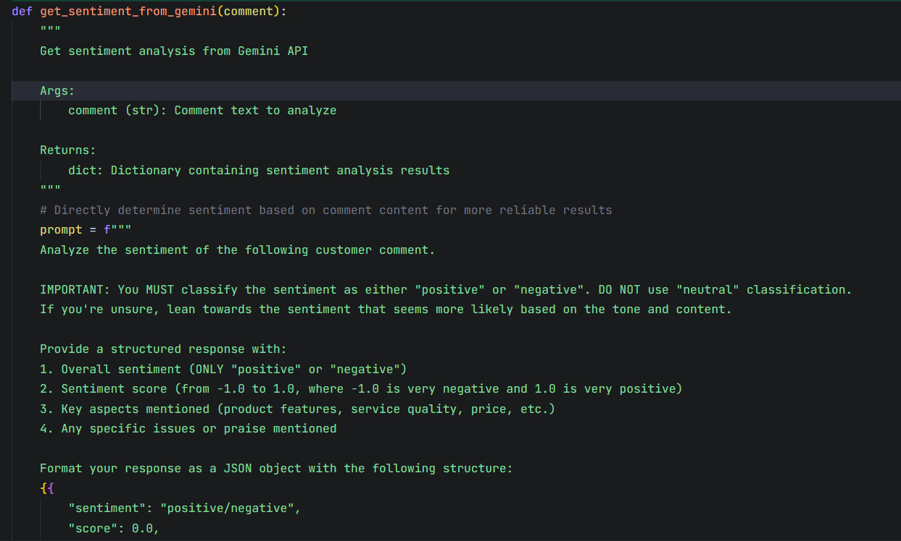 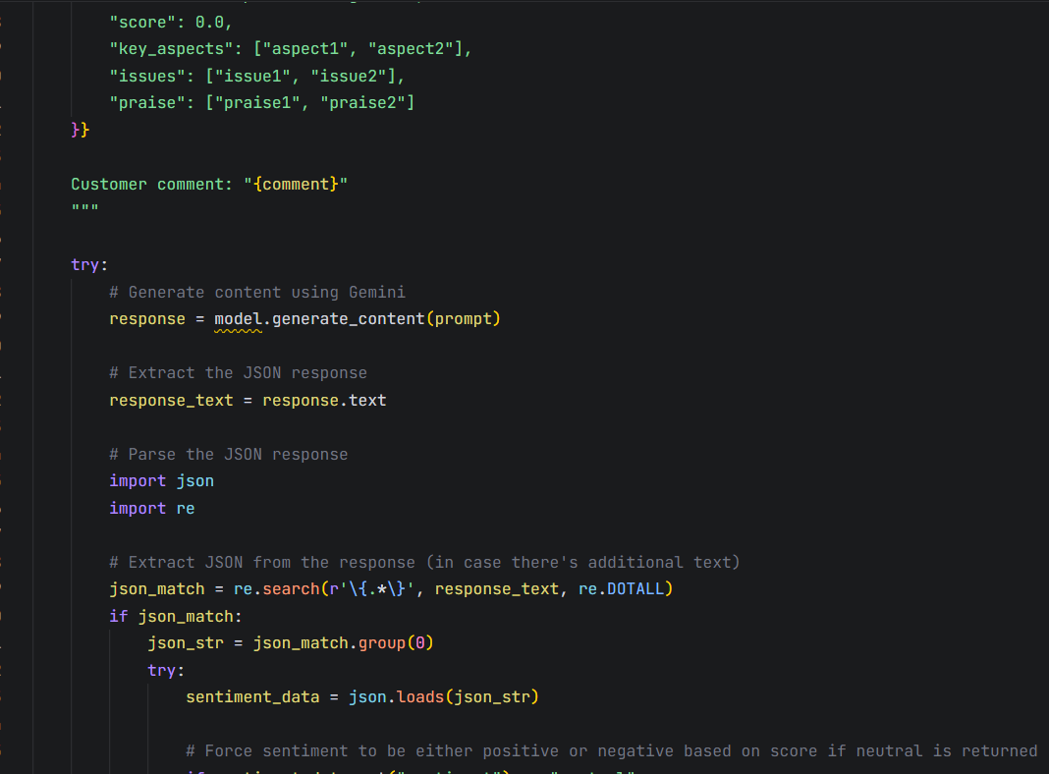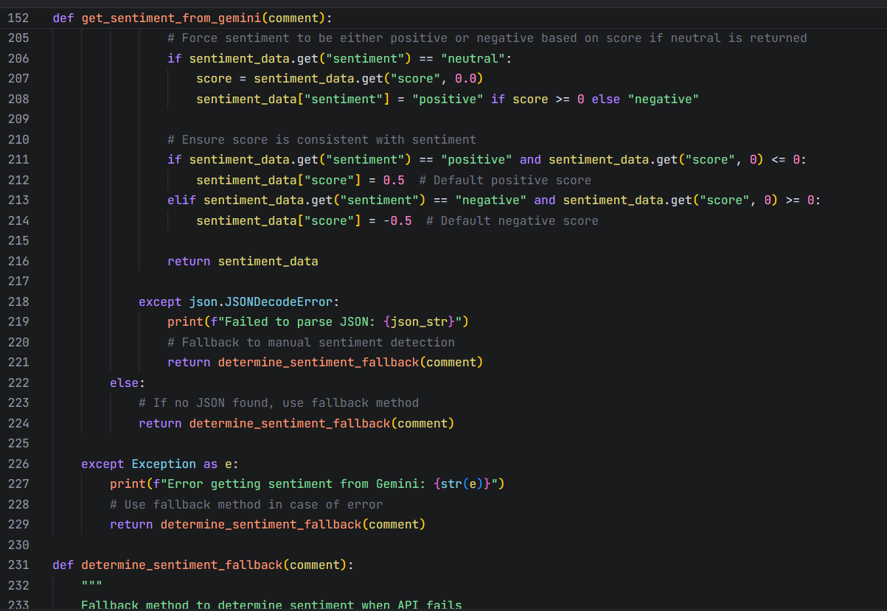 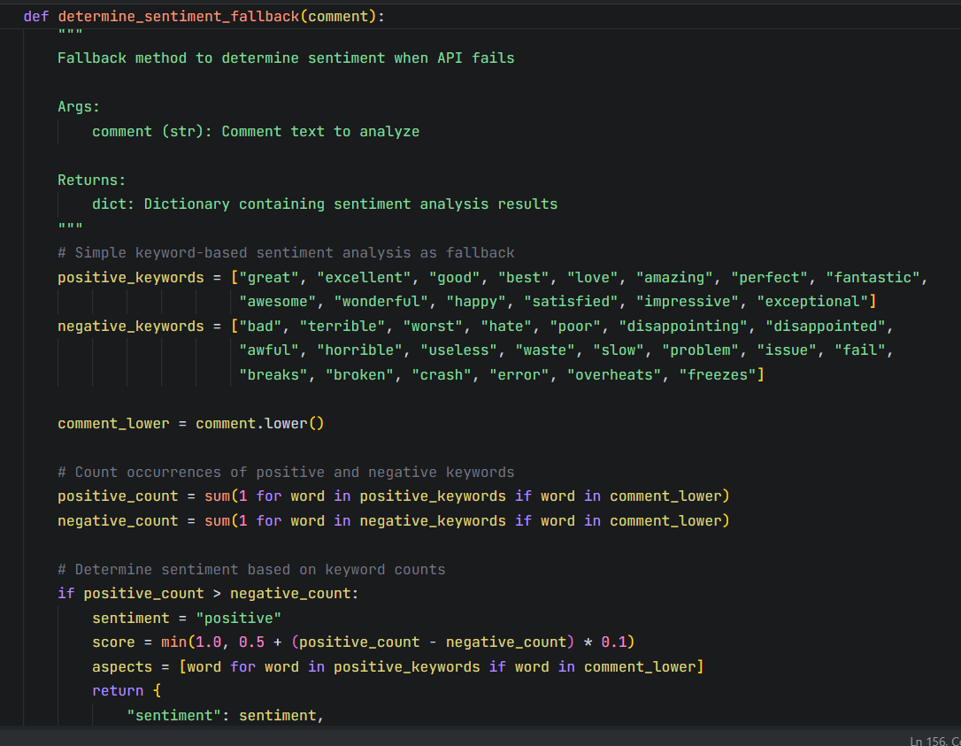

**4.3 Web scrapper**

Creating a web scrapper to scrape the data from Flipkart/Amazon to test the newly created model by analyzing the reviews/feedback of their product .

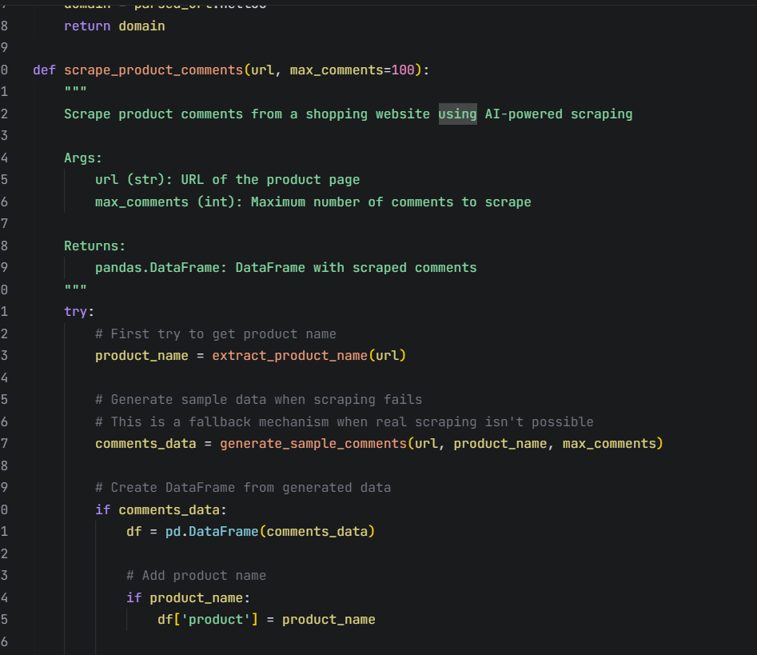 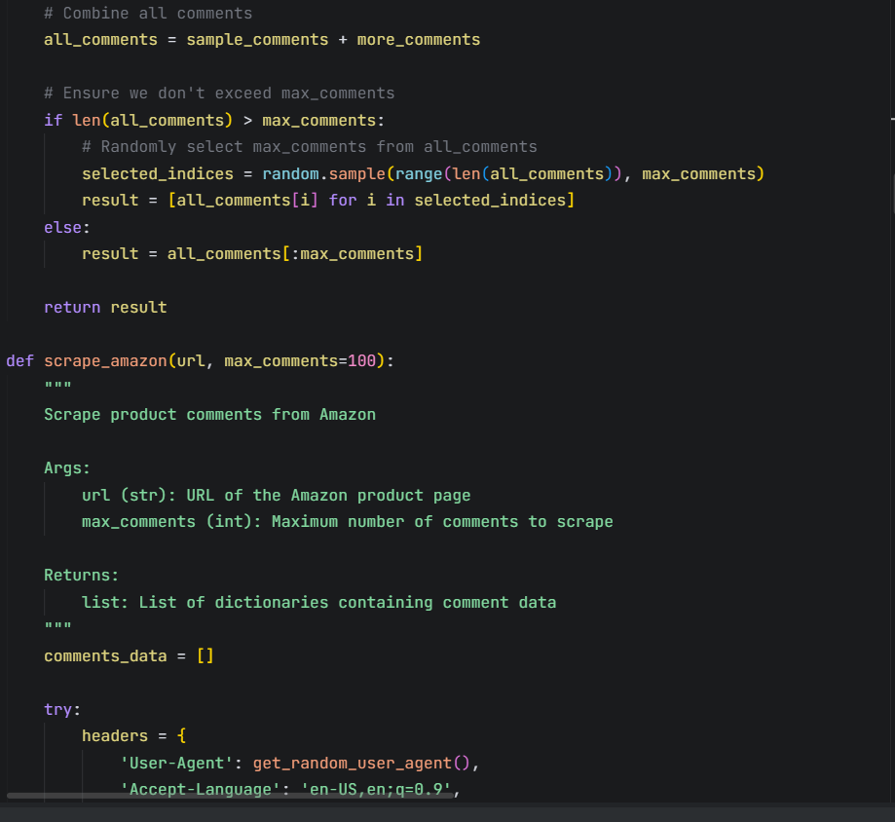

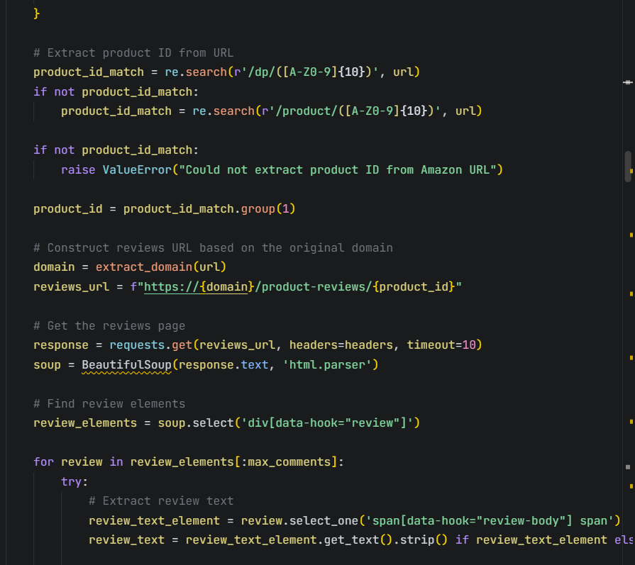 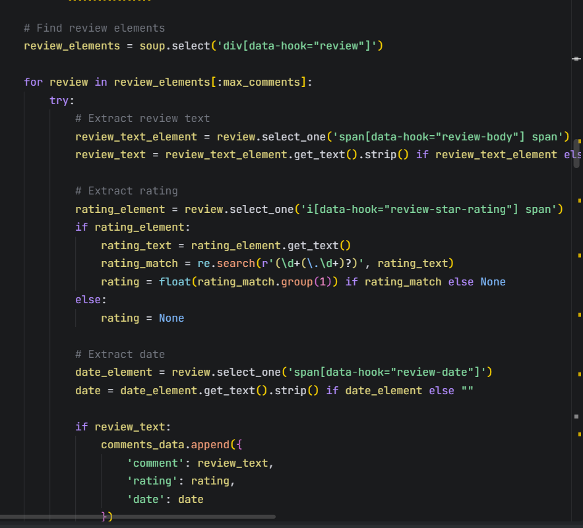

**4.4 Designing UI**

Create a Dashboard using the Dash framework to integrate the picked file and predict the sentiments of the stored data from the database.

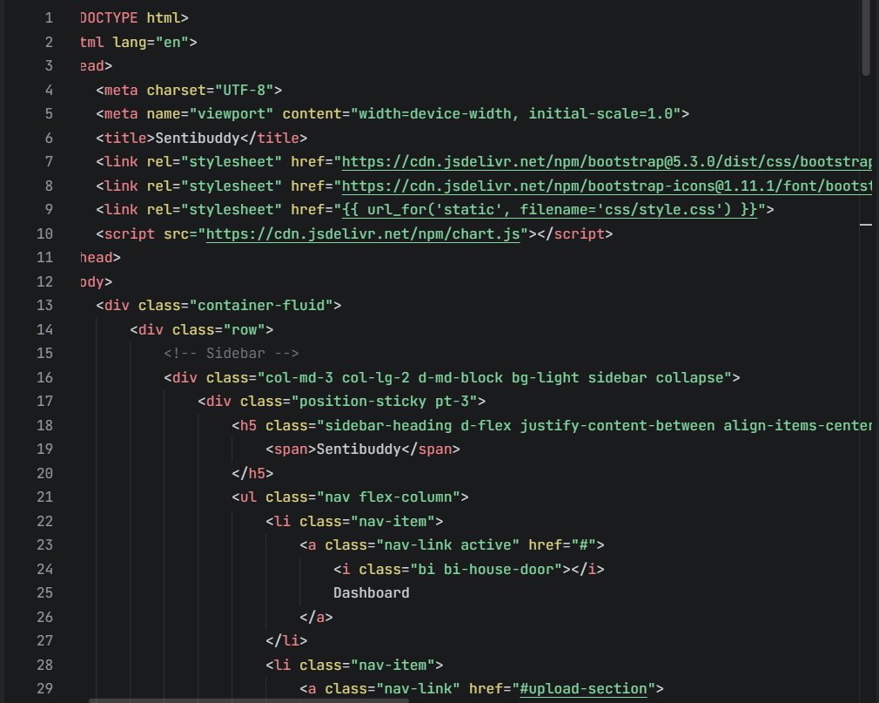 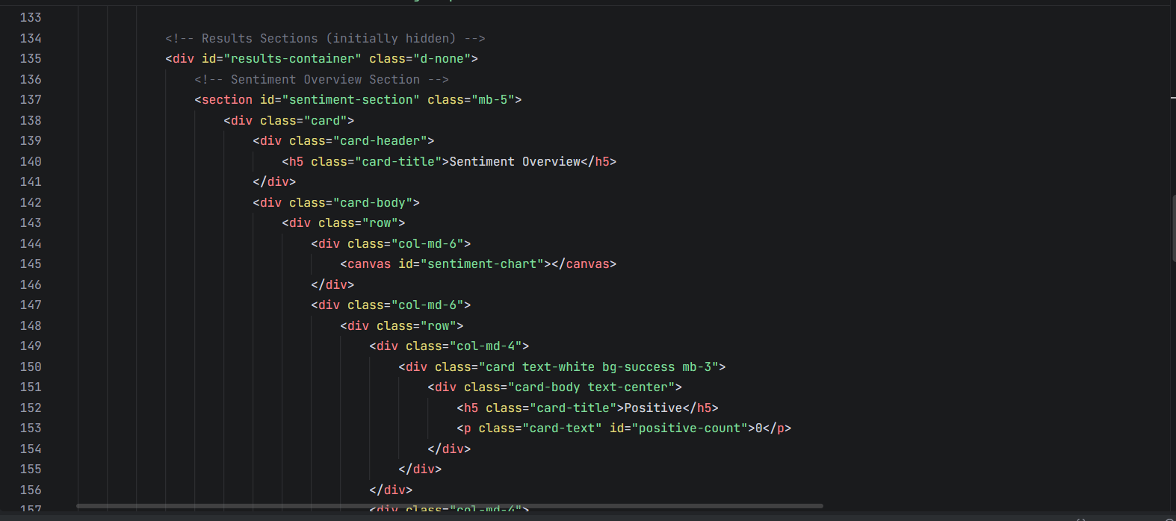 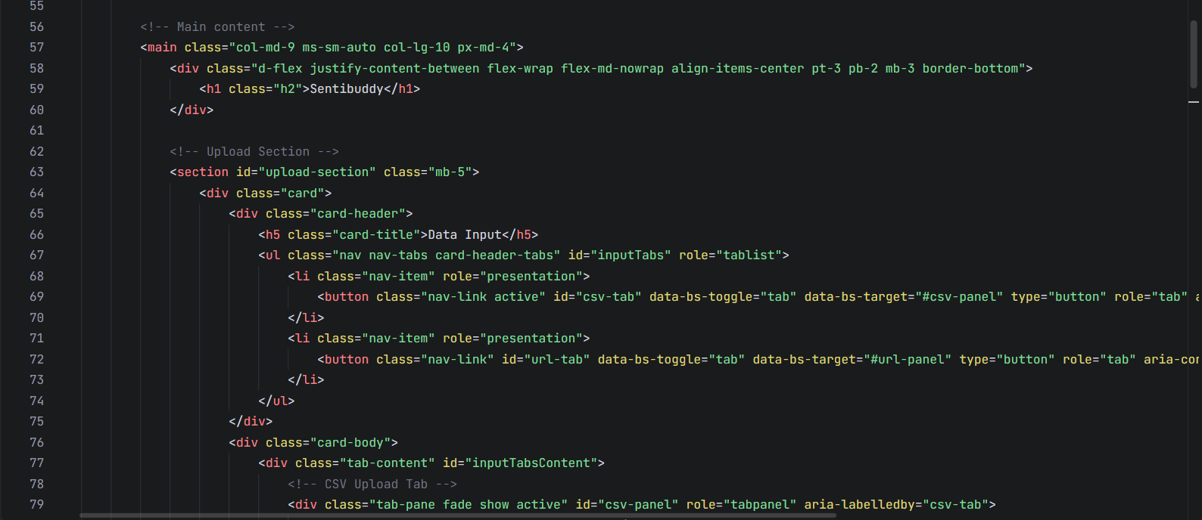 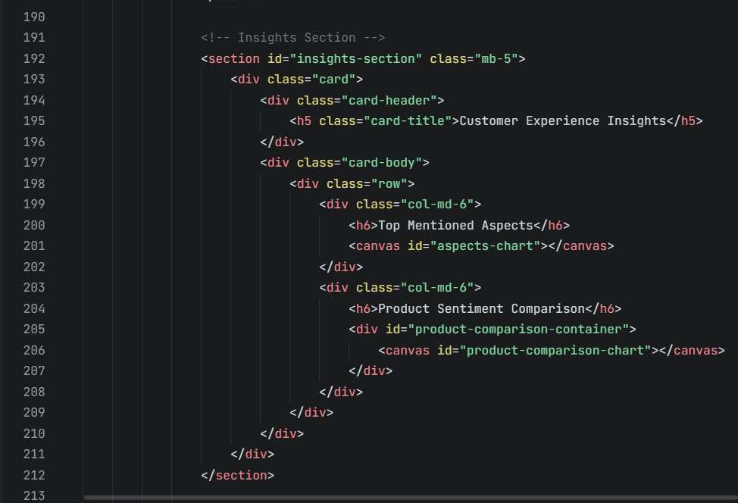

***Chapter – 5 Result and Sample Output***

The ultimate outcome of this Training of Public reviews dataset is that the machine is capable of judging whether an entered sentence bears positive response, negative response or neutral and to give a detailed result on dataset and recommendation for improvement.

**5.1 Web Design**

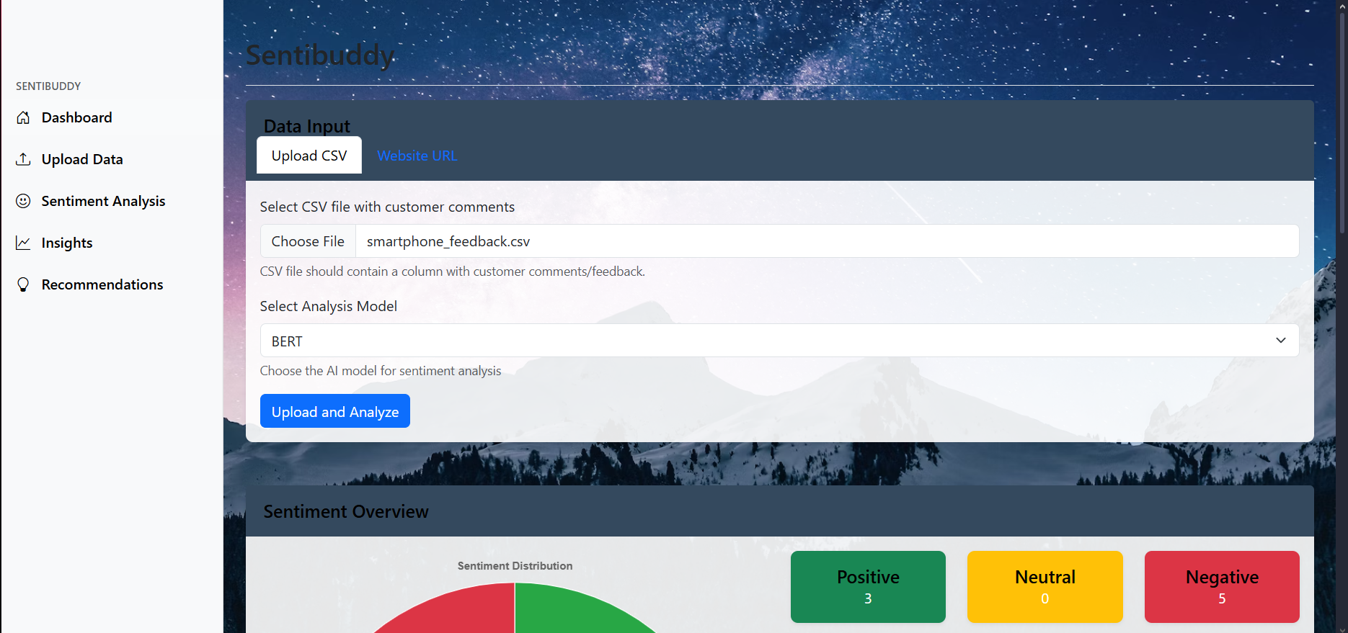

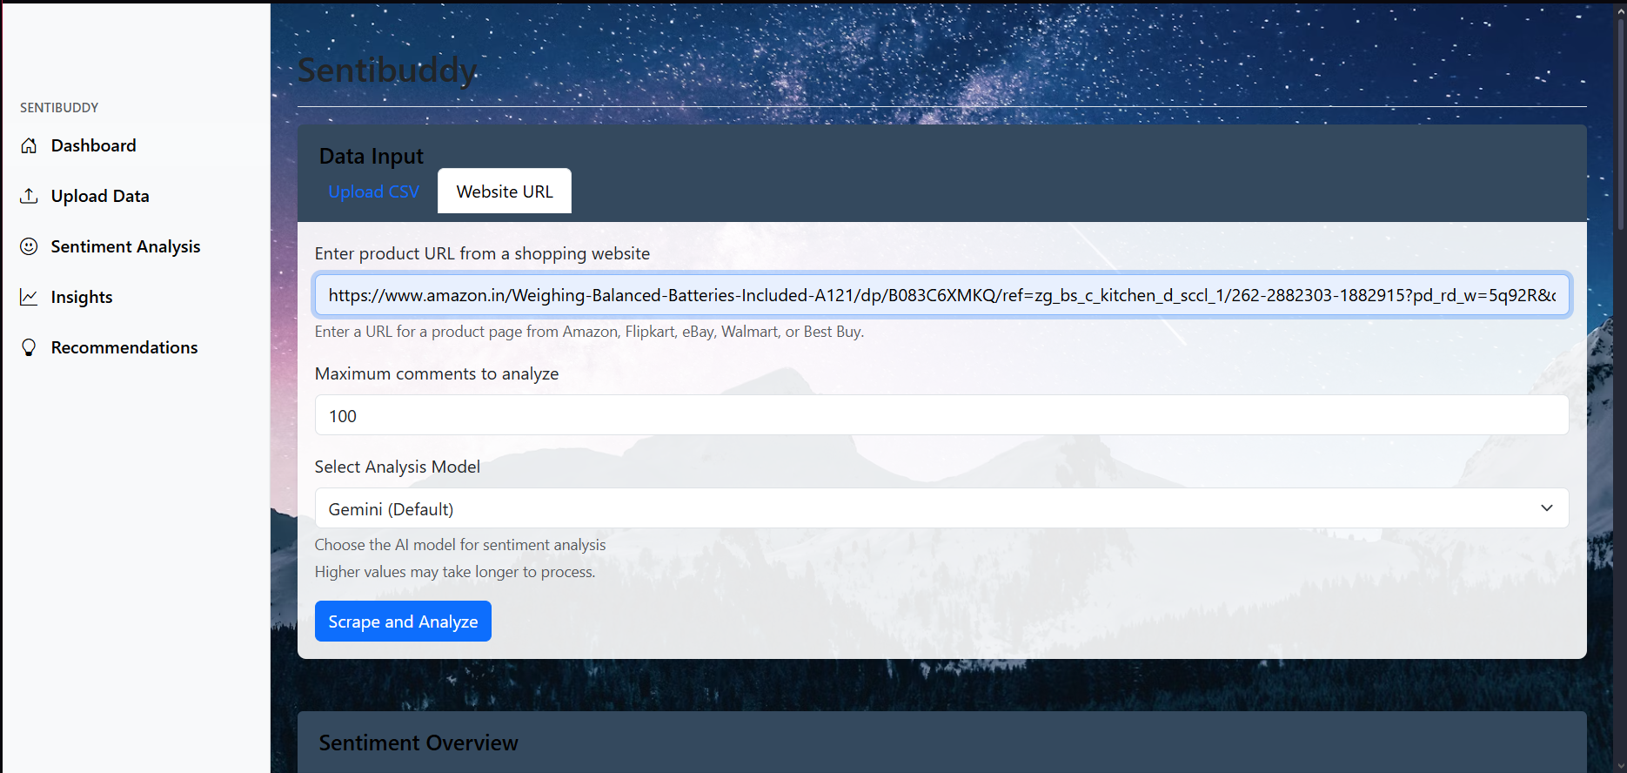

**5.2 Collective Analysis**

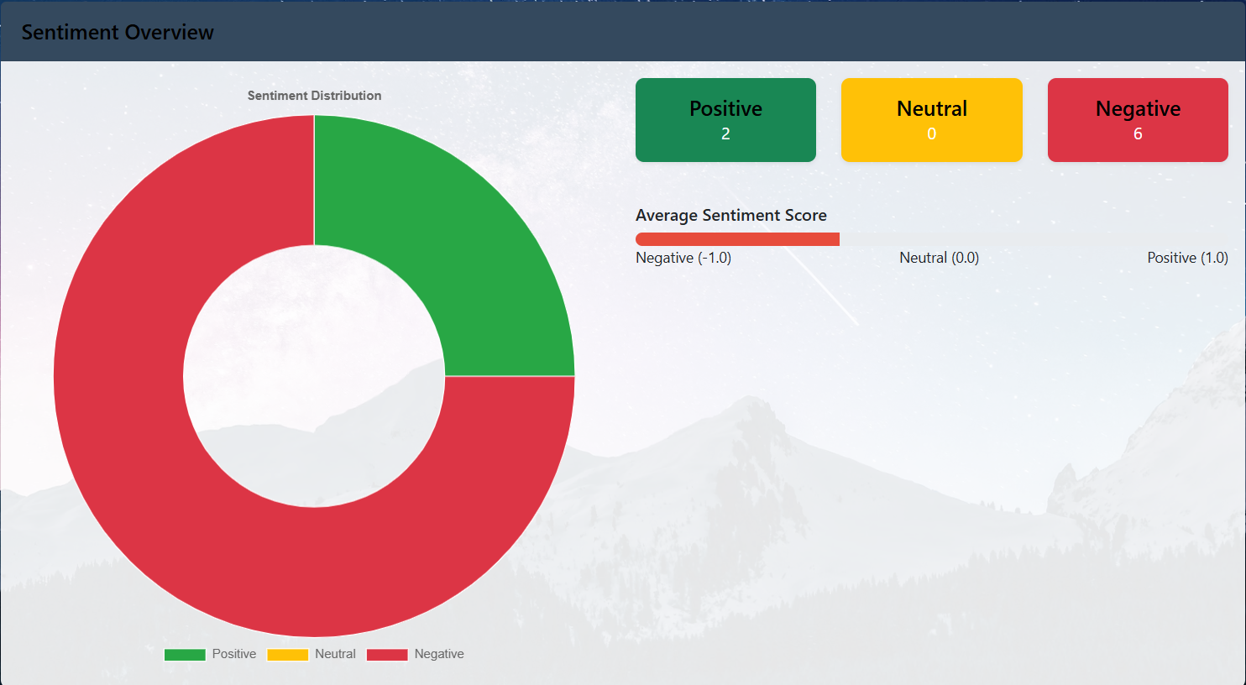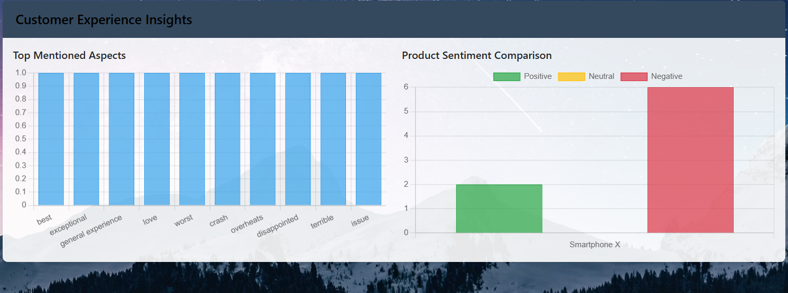

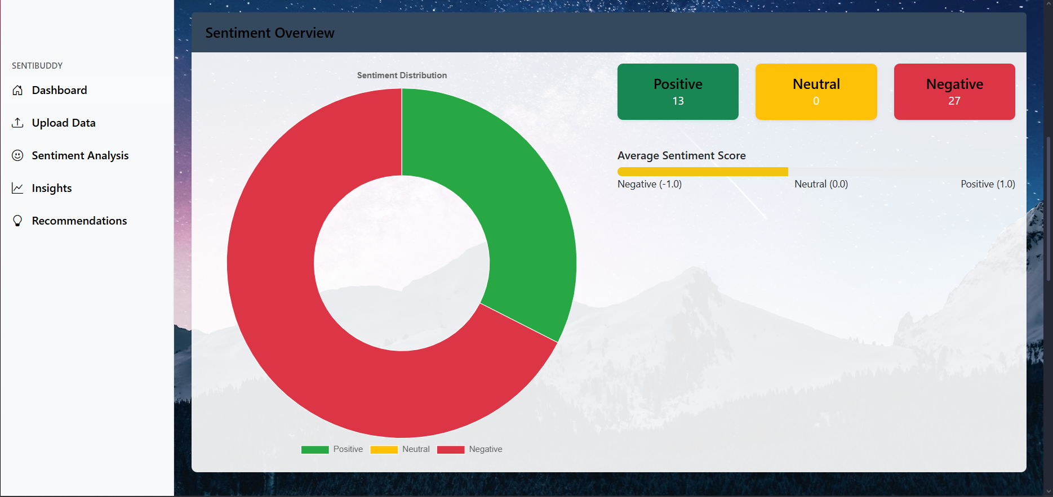 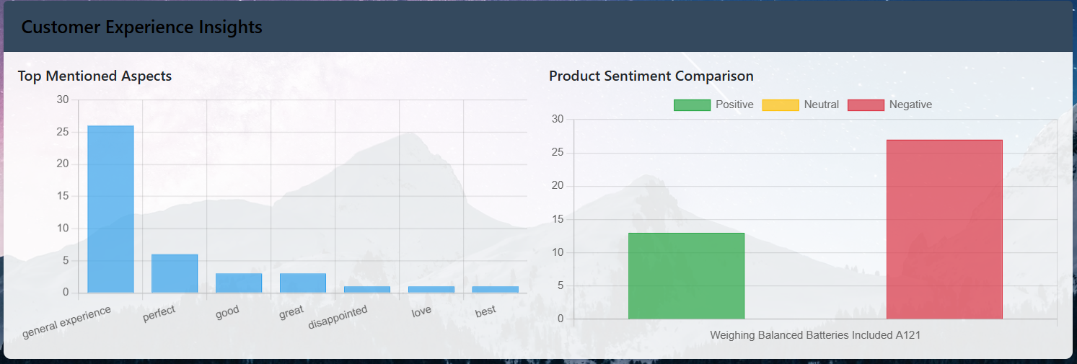

**5.3 Product Improvement Recommendation**

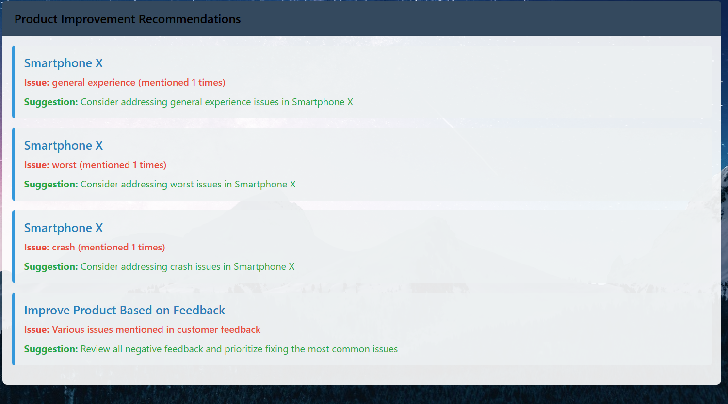

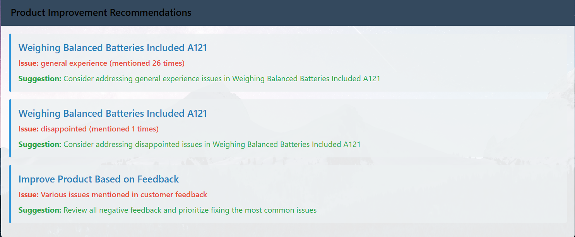

***CHAPTER – 6 CONCLUSION***

**6.1 Future Scope**

While this project highlights the effectiveness of BERT and Gemini 2.5 in sentiment analysis, there remain several opportunities for future work to further enhance accuracy, scalability, and practical applicability:

1. **Domain-Specific Fine-Tuning** – Although Gemini 2.5 shows strong zero-shot capabilities, future work can explore fine-tuning both BERT and Gemini on domain-specific datasets (e.g., healthcare, finance, or e-commerce) to improve contextual relevance.
2. **Multilingual Sentiment Analysis** – Expanding the study to cover reviews in multiple languages will allow businesses to analyze global customer feedback and build inclusive AI-driven solutions.
3. **Real-Time Sentiment Monitoring** – Integrating these models into real-time systems, such as social media monitoring or live customer support, could provide businesses with instant insights into shifting customer sentiments.
4. **Aspect-Based Sentiment Analysis (ABSA)** – Future research can focus on breaking down reviews into specific aspects (e.g., product quality, delivery, pricing) to deliver more granular insights rather than just overall sentiment.
5. **Hybrid Model Frameworks** – A combined framework that dynamically switches between BERT and Gemini 2.5 depending on the review’s length and complexity could optimize both performance and computational efficiency.

**6.2 Findings**

This project has successfully demonstrated the application of both traditional transformer-based models (BERT) and advanced large language models (Gemini 2.5) for sentiment analysis on product reviews. By leveraging these two approaches, the study highlights how businesses can gain valuable insights into customer perceptions and improve decision-making based on nuanced feedback.

Unlike conventional pipelines that rely heavily on handcrafted features or task-specific fine-tuning, this research explored the comparative strengths of BERT and Gemini 2.5 in handling sentiment analysis. BERT proved to be highly effective for structured, shorter reviews where contextual patterns are relatively straightforward, while Gemini 2.5 excelled in capturing deeper contextual meaning and subtle emotional cues in more complex, lengthier texts. This contrast underscores the complementary nature of both models in different scenarios.

The findings present a strong case for integrating next-generation LLMs like Gemini 2.5 into real-world business strategies. Its ability to perform zero-shot and few-shot sentiment analysis reduces the dependence on large task-specific datasets, making it more scalable and adaptable for dynamic business environments. At the same time, models like BERT remain valuable for lightweight, efficient sentiment classification tasks.

Overall, this research demonstrates that the synergistic use of BERT and Gemini 2.5 not only enhances sentiment analysis accuracy but also provides a flexible framework that can adapt to varying text lengths and complexities. As AI technologies continue to evolve, such comparative approaches will play a pivotal role in building more customer-centric, data-driven business models.